Easiest way to make $10k (or more!)/month as a writer (without a portfolio)
May 05, 2025

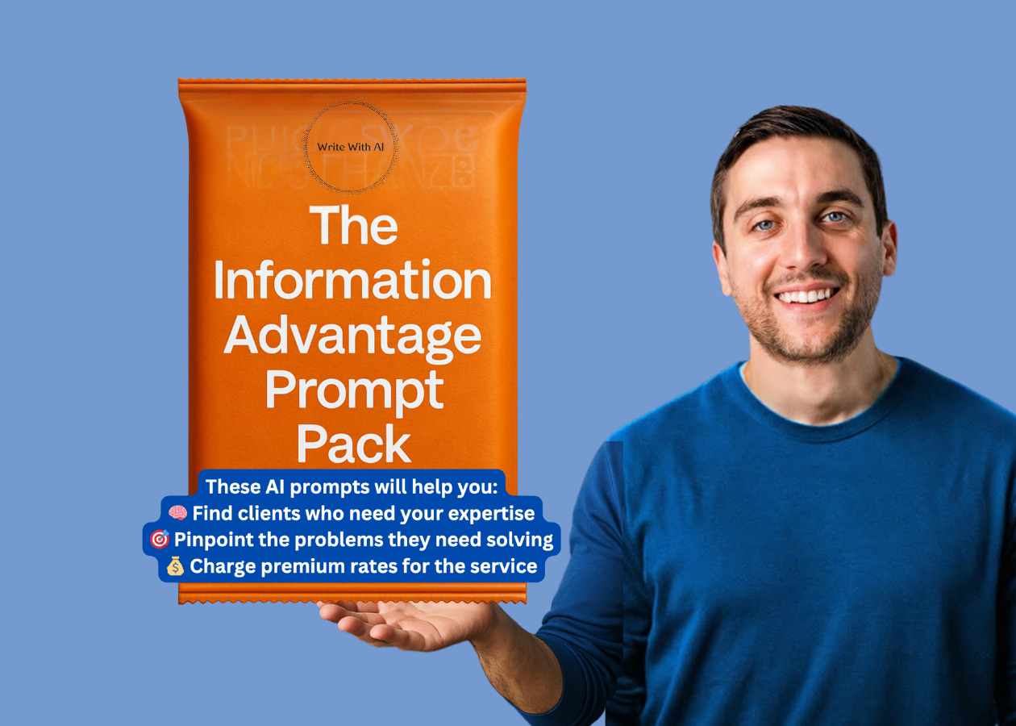

Today, I want to share with you the fastest path to landing high-paying writing clients.
And no, you don't need to:
- Have a massive portfolio.
- Or collect dozens of testimonials.
- Or even have years of professional writing experience.
Because if that's all it took, every English major would be making six figures from their laptop.
But the truth is that most writers don't have a skill problem. They have a positioning problem—especially when they're just getting started.
So, if you want to be one of the lucky handful of writers in the world getting paid very well to write, here's how:
Step 1: Uncover Your Information Advantage
Every aspiring writer has the same question on Day 1:
"How do I get clients without experience?"
But chasing clients with resumes and sample work actually makes it harder to land high-paying gigs. Because the truth is, you already have something more valuable than any portfolio.
It’s your "Information Advantage."
Your Information Advantage is the knowledge you've built over the last 10+ years that you know better and more naturally than the average person.
It could be:
- Your day job expertise
- A skill you've mastered
- A hobby you're obsessed with
- An industry you've worked in
- A problem you've solved
This is your secret weapon in the writing market.
Step 2: Leverage Your Information Advantage For Income
Most writers start trying to monetize their writing by being generalists.
While you totally "can" take this path if you want, just know that it's a lot harder to make good money. Because instead of competing with thousands of general writers for $50 gigs, you could land a $5,000 project from a client who needs your specific expertise.
For example, writers with Information Advantages get paid $3,000-$10,000+ to:
- Write newsletters for companies in industries they know inside-out
- Create social posts for brands where they understand the audience's language
- Ghostwrite for experts in fields they've worked in
- Write sales copy for products where they know the customer's pain points
But the question we always get asked is:
"How do I actually turn my knowledge into writing income?"
That's exactly what we'll cover in the next 4-days:
- Day 1: Spot your Information Advantage. We'll help you identify the knowledge areas where you have unique insights that clients will pay premium rates to access.
- Day 2: Find the perfect clients. You'll discover exactly where to find clients who desperately need your specific expertise (and are willing to pay top dollar for it).
- Day 3: Package your knowledge. Learn how to position your writing services to command $1,000+ rates from day one.
- Day 4: Land your first high-value client. Get a step-by-step outreach plan that bypasses the usual pitching process.
And the best part?
Each day comes with a ready-to-use AI prompt, so you can drop it straight into ChatGPT or Claude and start seeing results immediately.
Here's why this approach works so well:
When you leverage your Information Advantage:
- You instantly stand out in a crowded market of generalist writers
- You speak the language your potential clients use
- You understand the problems they're trying to solve
- You skip the portfolio review because your expertise becomes more valuable than your writing samples
- You command premium rates because you're selling expertise, not just words
This is exactly how Dickie earned his first $10,000 as a ghostwriter.
He wrote 1 curation thread every day for 30 days, bringing together all the thinking of a particular founder/executive/creator he looked up to. After his 30th thread, he got a private message from someone asking if he would be willing to do a curation thread based on their insights. He wanted Dickie’s help to scour the internet to find all a bunch of relevant content, closely study it, and organize it in a way that could eventually serve as a rough outline for a book.
Why Dickie?
Because knew how to distill content on the internet.
He had an Information Advantage.
Pretty cool, right?
Tomorrow, we'll start by finding your Information Advantage.
Chat soon,
—Dickie & Cole

